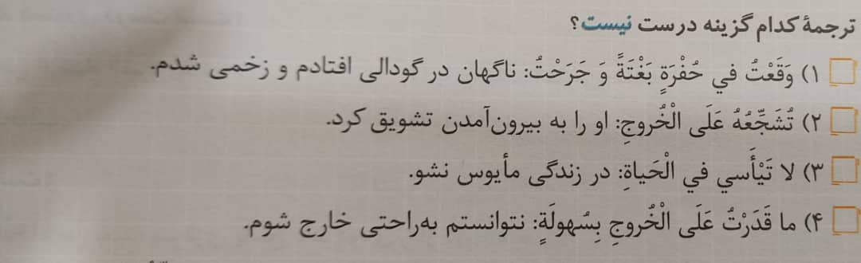

گزینه 2

-------------------------------------------------------------------------------------------------------------------------------------

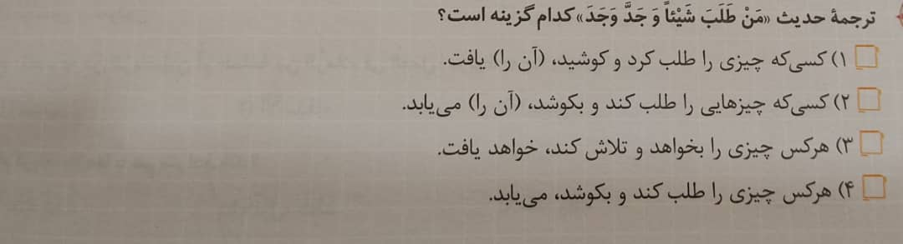

گزینه 4

-------------------------------------------------------------------------------------------------------------------------------------

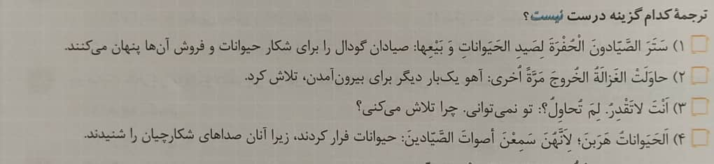

گزینه 1

-------------------------------------------------------------------------------------------------------------------------------------



گزینه 3



گزینه 4

-------------------------------------------------------------------------------------------------------------------------------------



گزینه 2

-------------------------------------------------------------------------------------------------------------------------------------



گزینه 3

-------------------------------------------------------------------------------------------------------------------------------------

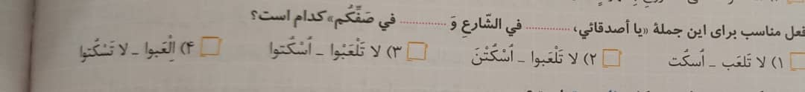

گزینه 3

-------------------------------------------------------------------------------------------------------------------------------------



گزینه 4

-------------------------------------------------------------------------------------------------------------------------------------

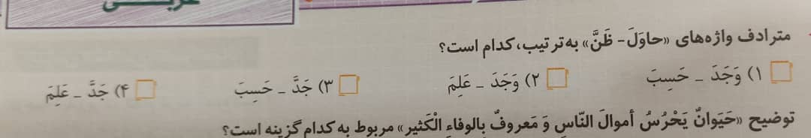

گزینه 3